MASTERS THESIS
DESIGN AND IMPLEMENATION OF DIGITAL IIR FLTER USING FOLDING TRANSFORMATION FOR LOW POWER VLSI APPLICATION

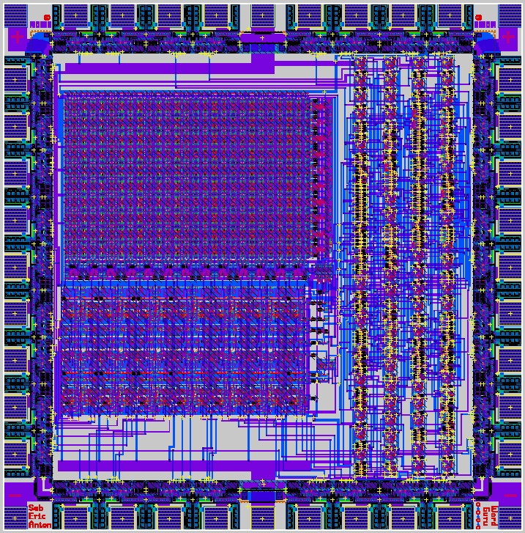

A master thesis report submitted to
the Faculty of University of Bridgeport
in partial fulfillment of the
requirements for the degree of

MASTERS OF SCIENCE

in the Department of Electrical Engineering

By
Mansi Patel
(Student ID: 0692597)
B.E (Electrical Engineering), Gujarat University, India, June, 2004

August, 2008
Thesis Advisor: Dr. Ausif Mahmood
University of Bridgeport, Bridgeport, CT-06604

